**GAME-3111 Advanced Graphics Programming**

**Assignment #1**

**Doosung Jang #101175013**

**Junho Kim #101136986**

**1. The Info of Buildings Names in Our City.**

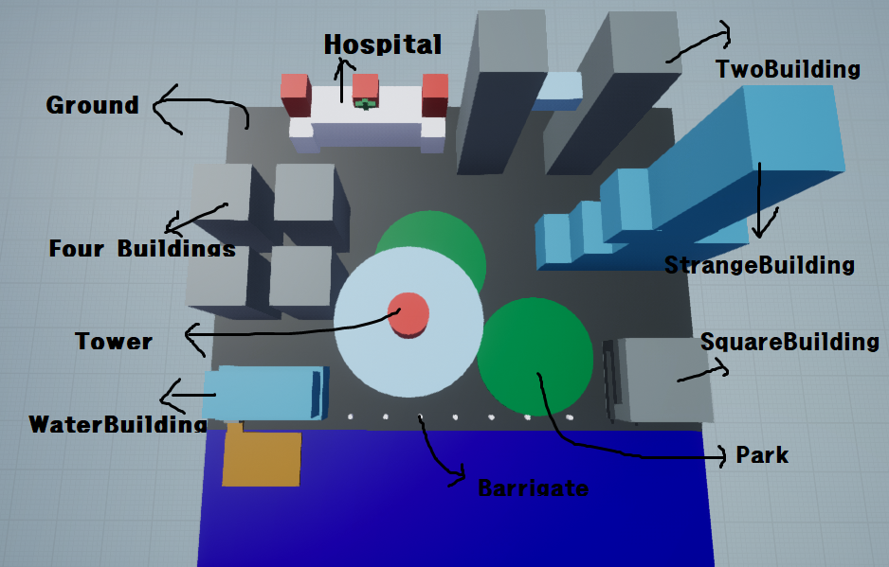

(All the sketch made by Unreal Engine 4)

**2. The Coordinates of Buildings. (x, y, z)**

- Ground: (0 0 0)

- Hospital (-5, 1, 12)

- Four Buildings (-11, 5, 5)

- Water Buildings (-10, 1.5, -11)

- Strange Building (12, 2, 2)

- Two Buildings (5, 5, 12)

- Square Building (12, 2, -11)

- Tower (0 0 -4)

- Park: two parks ( 3, 0 ,-5) and ( -3, 0, 7)

- Barricade: The one which is left side of water building is (-13, 0, -14.5)

The one which is right side of water building is (13, 0, -14.5), and other right side barricades are -2 from the X-axis.

**3. The Sketches** (All the sketch made by Unreal Engine 4)

